Lesson 5 plan: Modelling
About the lesson
This lesson looks at the use of spreadsheets for modelling. Students will consider some of the different ways that spreadsheets can be used to model situations. They will learn how to use Goal Seek to solve ‘what-if’ questions. They will then apply this learning to practical activities using the spreadsheets provided.
Learning objectives
By the end of this lesson, students will
- understand how spreadsheets can be used to model situations.
- be able to develop a spreadsheet so that different scenarios can be tested.
- be able to use Goal Seek to answer what-if questions.
National Curriculum
The following subject content from the KS3 National Curriculum is included in this lesson:
- Design, use and evaluate computational abstractions that model the state and behaviour of real-world problems and physical systems.
- Understand the hardware and software components that make up computer systems.
Links
Modelling is used in many real-world situations and has links to many other subjects, including design and technology, geography, maths and the sciences.
Key terminology
modelling, Goal Seek
Teaching and learning activities
Share the objectives for the lesson with students (Slide 2 of Lesson 5 presentation).
Starter
Show students an image of a weather forecast (Slide 3).
Ask: How do you think weather forecasts are made?
The current weather conditions (temperature, pressure, humidity and wind speed) are compared to historical data, and very complex algorithms are used to predict what is likely to happen based on what has happened in the past.
Ask: Why are weather forecasts important?
They can help shops decide whether they need to stock up on ice creams for sunny weather or umbrellas for rainy weather and they can help councils decide if roads need to be gritted because there is likely to be snow.
Part 1
Explain modelling (Slide 4 and page 26 of the Student Book).
Ask: Can you think of other situations where modelling might be used? Compare responses to suggestions on next slide (Slide 5 and page 26 of the Student Book).
Epidemiology is the study of ‘how often diseases occur in different groups of people and why’ (www.bmj.com/about-bmj/resources-readers/publications/epidemiology-uninitiated/1-what-epidemiology).
Demonstrate the use of a spreadsheet for modelling (Slide 6, plus Video 5.1).
Ask students to complete Activity 5.1: Sweet shop (Slide 7, Excel workbook 5, sheet 1/Excel workbook 5.1; Google sheets workbook 5, sheet 1/Google Sheets workbook 5.1).
- Make sure that students complete the tasks sequentially.
- Check that the appropriate cells have been formatted as currency.
- Check that the formula in cell D13 is =B13*C13/100
- Check that the function in cell D21 is correct: =SUM(D13:D20)
- Check that the formula in cell D23 is correct: =D25-D21
- Check that the conditional formatting has been applied correctly.
Part 2
Explain the concept of Goal Seek and demonstrate how it can be used (Slide 8, plus Video 5.2 (Excel) and Video 5.2 (Google sheets)).
Ask students to complete Activity 5.2: Cupcake challenge (Slide 9, Excel workbook 5, sheet 2/Excel workbook 5.2; Google Sheets workbook 5, sheet 2/Google Sheets workbook 5.2).

Answer
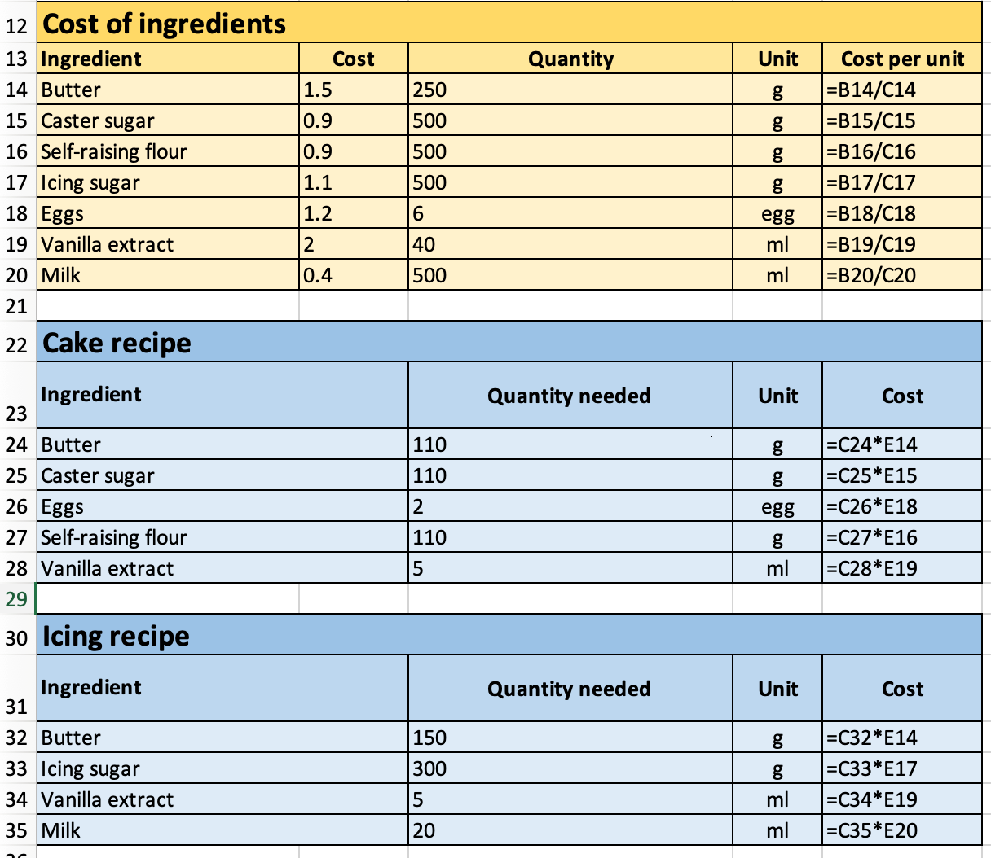
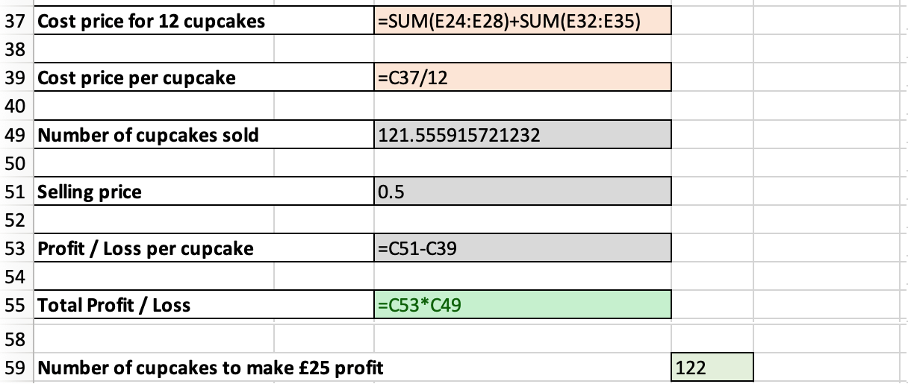

- Make sure that students complete the tasks sequentially.
- Check that appropriate cells have been formatted as currency.
- Check that the formula in cell E14 is =B14/C14
- Check that the formula in cell E24 is =C24*E14
- Make sure that the formulae to calculate the cost of the other ingredients for each recipe are referencing the correct cost per unit from the first table. For example, the formula in cell E28 should be =C28*E19.
- Check that conditional formatting has been used correctly. If the value of C55 is less than 0 it should have a pale red fill and if the value is more than 0 it should have a pale green fill.
- Make sure that goal seek is used correctly to change the value in cell C49.
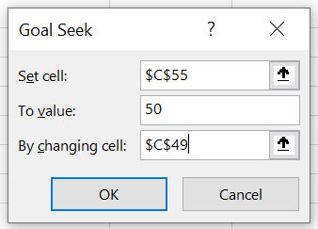
Plenary
Check students’ knowledge and understanding with a short question and answer session linked to the learning objectives for the lesson.
- What is meant by modelling?
(Example answer: It is a process that allows us to predict what is likely to happen when something changes.)
- Why are spreadsheets good to use for modelling?
(Example answer: Spreadsheets are good to use for modelling because they are easy to set up, then perform calculations on data and you can try out lots of different scenarios to find the best result.)
- What does Goal Seek enable you to do?
(Example answer: Goal Seek enables you to ask what-if questions to achieve a specific goal.)
Homework
Ask students to complete Quiz 5.
Stretch activities
Students who complete the activities in this lesson quickly could be encouraged to use goal seek for a range of different scenarios. For example, working out the optimum selling price for a batch of 500 cupcakes to make a total profit of £75.

Support activities
In the Sweet Shop activity, some students may not realise that the cost per 100g needs to be divided by 100 to get the cost per gramme. Check that their formula for the cost is correct by entering a value of 100 in the quantity column; the resulting value should be the same as that shown in the ‘Cost per 100g’ column.
Some students may need support in calculating the cost of the ingredients needed for the cake and icing recipes in the cupcake challenge. Encourage them to use cell references linked to the ‘Cost per unit’ in the ‘Cost of ingredients’ table. Note that it is not possible to simply replicate the formulae in this activity.
A number of short and informative videos can be found online that demonstrate the use of features in spreadsheets such as: www.youtube.com/c/microsoft365/playlists?view=50&sort=dd&shelf_id=5 for MS Excel and www.youtube.com/channel/UCco3PQfioWg5uFBxi1ndb2A for Google Sheets.

